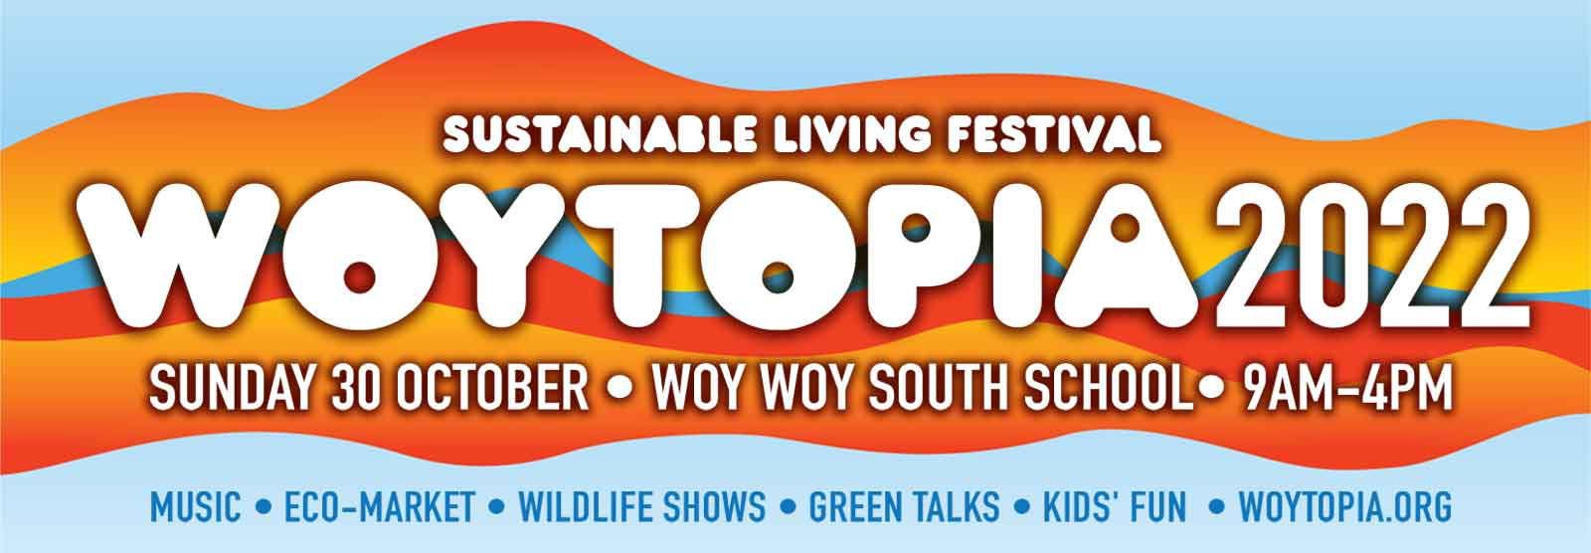
Stallholder application
Peninsula Environment Group (PEG) presents the Woytopia sustainable living festival, featuring sustainable living, music and arts in a relaxed, family-friendly community atmosphere. Woytopia is an opportunity to expose your organisation, business, products or services to a targeted market of eco-aware Central Coast residents.
- Based on seven previous Woytopia festivals since 2010, we expect approx. 3000 visitors.
- Attractions include talks/workshops, food stalls, music, dance, children’s activities and rides, etc.
- Extensive publicity campaign in local media and community networks.
How to book
1. Complete this form on your computer, save it and email it as an attachment to market@woytopia.org with a scan of your public liability insurance certificate. Put Woytopia stall in the email's subject line.
2. New stallholders: wait for us to email you confirmation your stall is approved before paying. (If you’ve had a stall at previous Woytopias, or we invited you to have a stall, you can send payment immediately.)
3. Food stalls: places limited so email market@woytopia.org to check availability before completing this form.
3. After your stall is approved, pay by bank transfer to: Peninsula Environment Group (Woytopia); BSB: 633-000; Account: 162818389. We’ll confirm your stall once we receive payment.
Public liability insurance
Stallholders must hold $10,000,000 Public Liability Insurance (and Product Liability Insurance if selling consumables). Please attach a photocopy or scan of your certificate of currency with your application.
Other conditions
1. We may refuse applications if a stall does not fit the sustainable living theme of Woytopia.
2. Stallholders must provide their own marquees, tables and equipment. Marquees must be weighted down. (Some stall pitches will be on astroturf and can’t be pegged down so you will need weights.)
3. No smoking, alcohol or dogs are allowed on school grounds.
4. Please minimise packaging. All packaging should be recyclable or biodegradeable. No single-use plastic bags. No bottle water sales. Please take any rubbish with you after the event.

Cancellation and refunds
1. If you cancel: full stall fee refund if you let us know in advance. No refund for no-shows on the day.
2. If we cancel: full stall fee refund. In the event of bad weather we may not cancel until the morning of the event, to give the event every chance of proceeding.
3. Food stalls: full stall fee refund if we cancel or you cancel before 16 October (two weeks before the event). No refund if you cancel after that date. We limit food stalls so if you cannot attend we need time to replace you or we will be short of food. This policy aims to ensure food vendors have a good day.

Vehicle access
Bump-in 6.15am-8.15am. Vehicles off-site by 8.30am. (Site access may get congested after 8am; let us know if you can come earlier). No vehicle access to site between 8.30am-4pm except by prior arrangement. Access to site is either from Waterloo Avenue or Balaclava Avenue and you will be sent a separate email with bump-in times and which entrance to use, please be prompt. You will be directed to your stall location on arrival.
Woytopia festival stallholder application
Business/organisation name:
Contact name:

Email:

On the day mobile phone:

Business hours phone (if same as above, leave blank):

On the day vehicle rego number (in case we need you to move your vehicle):

Bank transfer description you entered:

Payment / Type of organisation (put an X beside one option below)

Not for profit/community $65 Commercial/for profit $95
Food/beverage $145 Free/contra (by previous agreement only) $0

What goods/services do you sell, or what is the focus of your organisation?
Stalls should fit Woytopia's theme of environmental awareness, sustainable living, appreciation of the natural environment, or local artisan products. (A brief description is usually fine eg “organic jam” but say more if it’s not obvious why it fits Woytopia: eg jewellery might be handmade from recycled materials, fair trade, etc.)

Stall size/requirements
Stalls pitches are 3x3m. Stallholders must have a marquee. Marquees must be weighted (not pegged) down. Food stalls include power (state below if you need more than a 10amp connection). Non-food sites are unpowered. State below if you need extra space or have other special needs, or if your vehicle is larger than a ute/small van.

Access
About half of our sites require you to carry your marquee/gear about 20-30m. If you can take one of these sites it will leave the full vehicle access sites for those with heavy loads. We will have trolleys available to move gear. Please indicate below with an X.

I/we need full vehicle access I/we can carry our marquee/gear 30m

Anything else we need to know?

Declaration
I/we accept and agree to the terms & conditions outlined in this application form. (Please read preceeding notes.)

Name: Date:

